Software Engineering Quiz ch7~20

Quiz 7

1. What is domain analysis? Describe the steps of domain analysis**. (ch.6 超出期末範圍)**

2. What is software architecture?

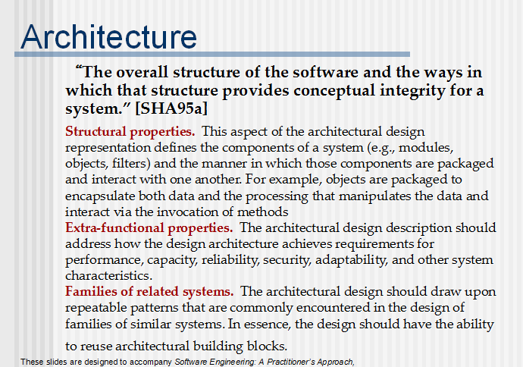

Quiz 8

1. Why software architecture is important?

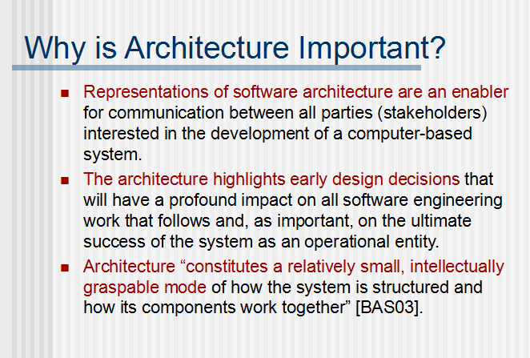

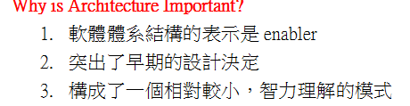

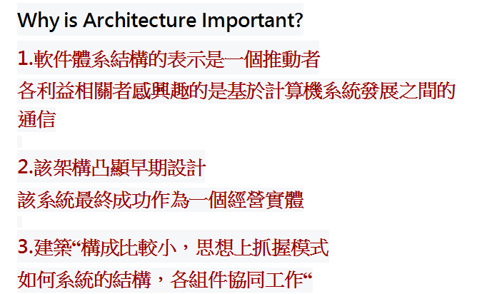

1. List the architecture styles.

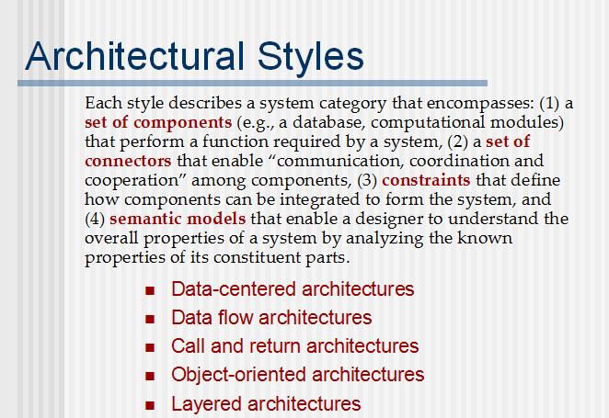

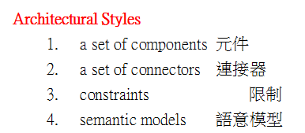

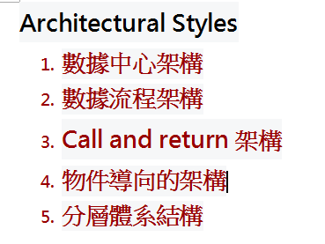

3. Describe why pseudocode is more popular than other algorithm design representations.

Quiz 9

1. List the design issues of interface design.

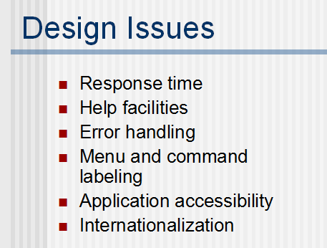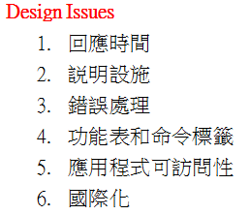

1. List kinds of design patterns

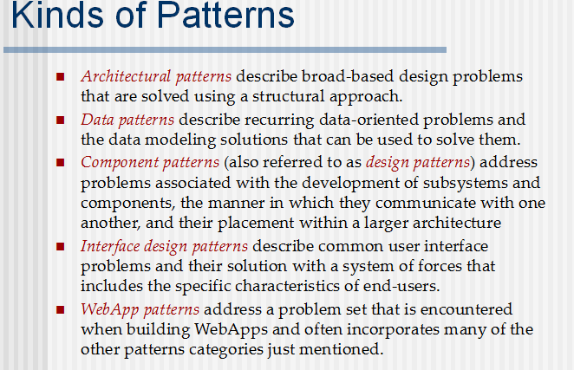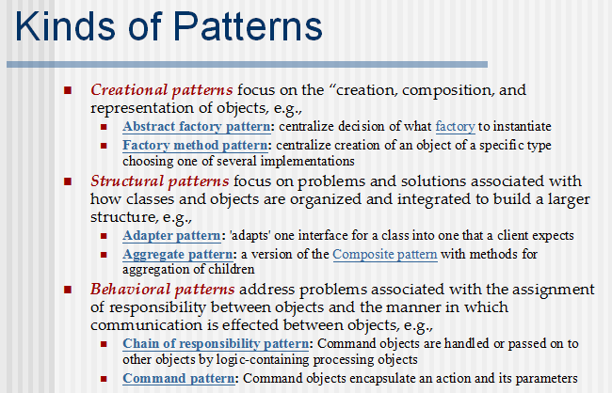

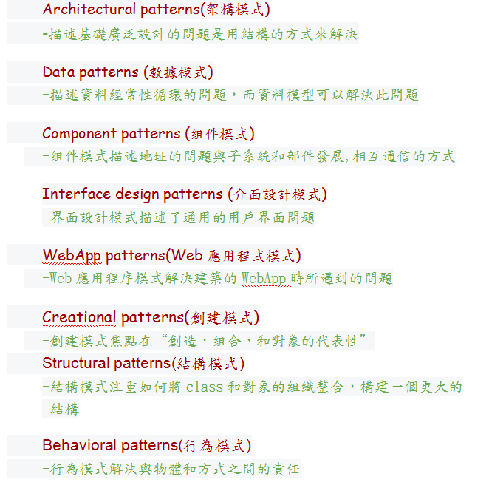

Quiz10

1. Describe quality dimensions for end users in Webapp design.

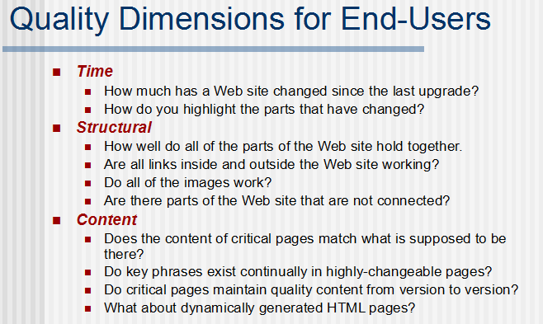

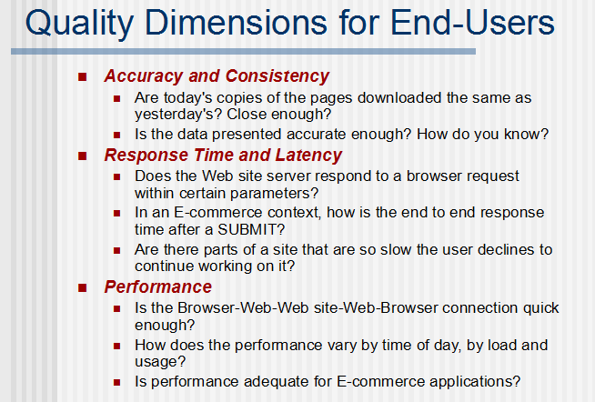  
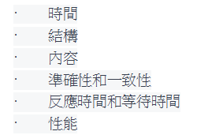

1. Describe McCall’s quality factors.

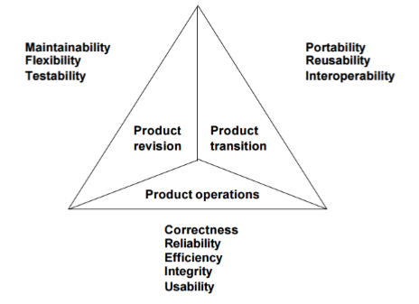

Quiz12

1. Describe the difference between white-box testing and black-box testing.

2. How to derive test cases in white-box testing.

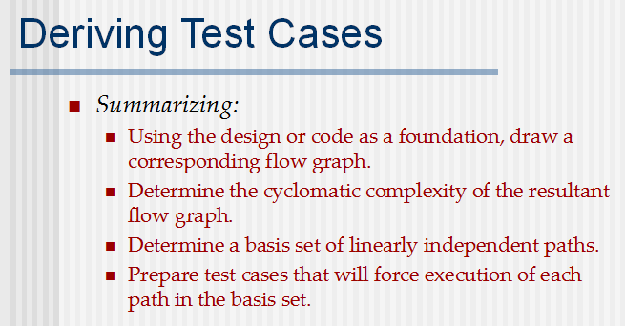

使用設計代碼作為基礎，繪製相應的流程圖

確定所得到的流程圖的圈複雜度

確定線性無關路徑的基組

準備將強制執行基礎集中的每個路徑的測試用例

3. How to do simple loop testing

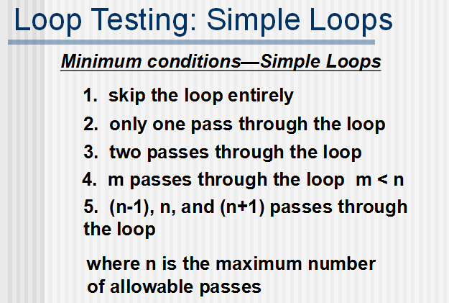

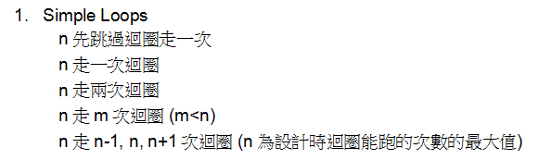

Quiz13

1. Describe object-oriented testing strategy.

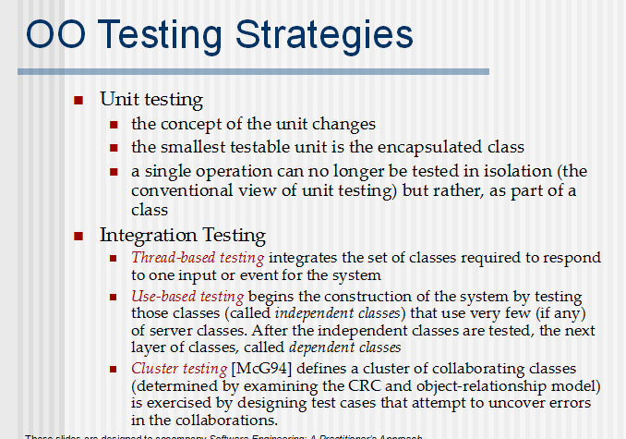

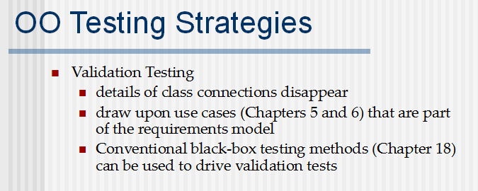

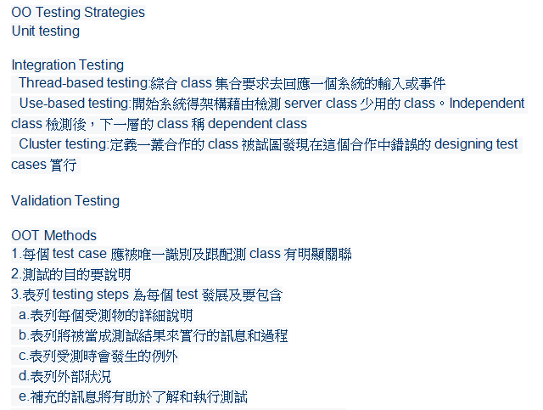

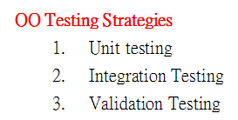

1. Describe testing quality dimensions of web application

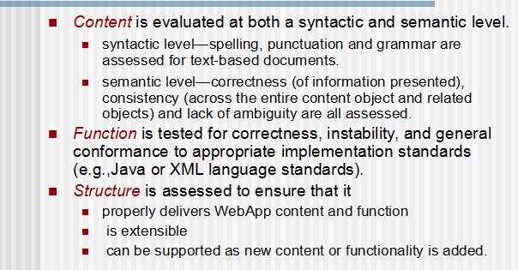

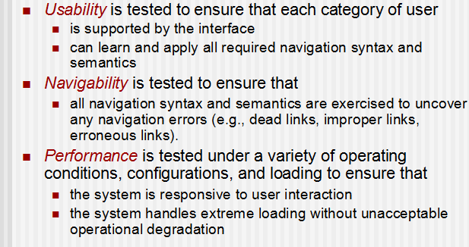

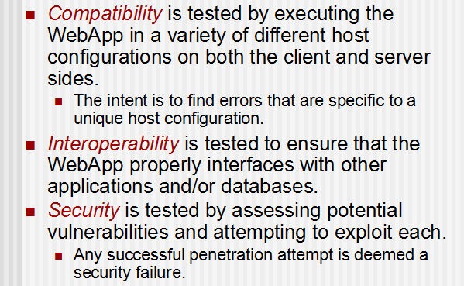

1. Describe testing process of web-app.

